1 Features of the development of use-case diagrams in the Umbrello UML Modeller environment
Practical 1

Table of Contents (Оглавление)
1 The aim of the laboratory work. (Цель выполнения лабораторной работы)
2 Theoretical material required for work. (Теоретический материал, необходимый для работы)
3 Example use case diagram
4 Laboratory assignment (Задание на лаб.раб.)
5 Instructions for performing laboratory work. (Инструкция по выполнению лаб. Раб.)
5.1 Create a use-case diagram.
5.2 Add an actor to the use case diagram and edit its properties.
5.3 Add and edit use case.
5.4 Adding an association.
5.5 Add dependency relationship and edit its properties.
5.6 Final construction of the use case diagram.

1 The aim of the laboratory work is
Создание диаграммы вариантов использования для программной системы «Банкомата», а также разработка ДВИ верхнего уровня для индивидуального учебного проекта.

2. Theoretical material required for work.
2.1 Semantic essence of the diagram (смысловая суть диаграммы)
Visual modeling in UML can be represented as a process of level-by-level descent from the most general and abstract conceptual model of the original system to the logical, and then to the physical model of the corresponding software system. To achieve these goals, a model is first built in the form of a so-called use case diagram. It describes the functional purpose of the system or, in other words, what the system will do during its operation. The use case diagram is the initial conceptual representation or conceptual model of the system during its design and development.
The development of a use case diagram is intended to:
• Determine the general boundaries and context of the modeled domain in the initial stages of system design.
• Formulate general requirements for the functional behavior of the designed system.
• Develop an initial conceptual model of the system for its subsequent detailing in the form of logical and physical models.
• Prepare source documentation for the interaction of system developers with its customers and users.
The essence of this diagram is as follows: the projected system is represented as a set of entities or actors interacting with the system using the so-called use cases. In this case, an Actor is any entity that interacts with the system from the outside. It can be a person, a technical device, a program or any other system that can serve as a source of influence on the simulated system as determined by the developer. In turn, the use case is used to describe the services that the system provides the actor. In other words, each use case defines a certain set of actions performed by the system during a dialogue with an actor. In this case, nothing is said about how the interaction of actors with the system will be realized.
The basic elements of the use case diagram are the use case and the actor.
2.2 Components of Use Case Diagrams (Компоненты диаграммы вариантов использования)
2.2.1 Use case
The design or standard element of the UML language use case is used to specify the general features of the behavior of the system or any other entity of the subject area without consideration of the internal structure of this entity. Each use case determines the sequence of actions that must be performed by the designed system when interacting with the corresponding actor. These actions are not depicted in the diagram. The content of the use case is presented in the form of an additional explanatory text, which reveals the meaning and sequence of actions when performing this use case. Such an explanatory text received the name of the script.
A separate use case is indicated on the diagram by an ellipse, inside of which its short name is contained in the form of a noun (Fig. 1.1, a) or a verb (Fig. 1.1, b) with explanatory words. The very text of the use case name must begin with a capital letter.

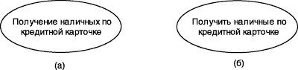
Fig. 1.1 – Graphical designation of the use case

The purpose of the use case specification is to define a complete aspect or fragment of the behavior of an entity without disclosing the internal structure of the entity. The source system or any other model element that has its own behavior, like a subsystem or class in a system model, can act as such an entity.
Each use case corresponds to a separate service that provides a simulated entity or system upon user’s (actor’s) request, i.e., determines how this entity is applied. The service, which is initialized by user request, is a complete sequence of actions. This means that after the system has finished processing the user's request, it should return to its original state, in which it is ready to perform the following requests.
Use cases describe not only the interactions between users and the entity, but also the reactions of the entity to the receipt of individual messages from users and the perception of these messages beyond the essence. The use cases may include a description of the features of the methods for implementing the service and various exceptional situations, such as the correct handling of system errors. The set of use cases in general should determine all possible aspects of the expected behavior of the system. For convenience, many use cases can be considered as a separate package.
Examples of use cases may include the following actions: checking the status of a client’s current account, placing an order for purchasing a product, obtaining additional information about a client’s creditworthiness, displaying a graphical form on a monitor screen, and other actions.
2.2.2 Actors
Actor – a consistent set of roles that play external entities in relation to use cases when interacting with them.
An actor is any external entity in relation to the system being modeled, which interacts with the system and uses its functionality to achieve certain goals or solve particular problems.
Actors are not part of the system - they represent someone or something that needs to interact with the system. Actors can:
• only provide information to the system;
• only receive information from the system;
• provide information and receive information from the system.
Usually the actors are determined from the description of the task or through negotiations with customers and experts. To identify the actors can be used the following group of questions:
1. Who is interested in a specific system requirement?
2. What role will the system play in the organization?
3. Who will benefit from using the system?
4. Who will supply the system with information, use the information and receive information from the system?
5. Who will support and maintain the system?
6. Does the system use external resources?
7. Does any member of the system act in multiple roles?
8. Do the various actors play the same role?
9. Will the new system interact with the old one?
The standard graphic designation of the actor in the diagrams is the "little man" figure, under which the name of the actor is recorded (Fig. 1.2).

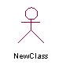
Fig. 1.2. Graphic actor

The name of the actor must be sufficiently informative from the point of view of semantics. Fully suitable for this purpose are job titles in a company (for example, salesman, cashier, manager, president). It is not recommended to give actors the names of their own (for example, "Alexander") or models of specific devices (for example, "Cisco 3640 router").
Examples of actants can be: bank customer, bank clerk, store salesman, sales manager, flight passenger, car driver, hotel administrator, cell phone, and other entities related to the conceptual model of the corresponding subject area.
Two or more actors can have common properties, i.e. interact with the same set of use cases in the same way. Such a commonality of properties and behavior is represented as the generalization considered below with another, possibly abstract, actor who models the corresponding commonality of roles.
2.2.3 Relationships in the use case diagram
There may be different relationships between the elements of the use case diagram. One actor can interact with multiple use cases. In this case, this actor refers to several services of this system. In turn, one use case may interact with several actors, providing their services for all of them.
At the same time, two use cases defined within one simulated system can also interact with each other, but the nature of this interaction will differ from the interaction with actors. However, in both cases, the methods of interaction of model elements involve the exchange of signals or messages that initiate the implementation of the functional behavior of the simulated system.
UML has several standard kinds of relationships:
• association relationship,
• include relationship
• extend relationship,
• generalization relationship.

The relation of association is one of the fundamental concepts in the UML language and is used to a greater or lesser extent in the construction of all graphic models of systems in the form of canonical diagrams. This relationship establishes what specific role an actor plays when interacting with an instance of a use case. In the use case diagram, as well as in the other case diagrams, the association relation is indicated by a solid line between the actor and use case. This line may have additional symbols, such as, for example, the name and the multiplicity (Fig. 1.3).

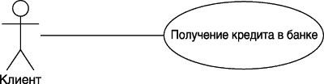

Fig. 1.3. An example of a graphical representation of an association relationship between actor and use case.

The multiplicity of the association is indicated next to the symbol of the chart component that is a member of this association. The multiplicity characterizes the total number of specific instances of this component that can act as elements of this association. For diagrams of use cases, the multiplicity has a special designation in the form of one or several numbers and, possibly, the special character "*". A more detailed description of the semantic features of the association relationship will be given when considering other diagrams.

The include relationship between two use cases indicates that some specified behavior for one use case is included as an integral component in the behavior sequence of another use case. This relationship is a directed binary relation in the sense that a pair of use case instances are always ordered with respect to inclusion.
The semantics of this relationship is defined as follows. The process of performing the base use case includes a sequence of actions that is defined for the use case to be included. In this case, the execution of the included sequence of actions always occurs when the base use case is initiated.
One use case may be included in several other options, as well as include other options. It is assumed that even if an instance of the first use case may have several included instances of other options, the actions they perform must have ended by some point, after which the interrupted actions of the instance of the first use case should continue in accordance with the behavior specified for it.
The inclusion relationship, directed from use case A to use case B, indicates that each instance of option A includes the functional properties defined for option B. These properties specialize the behavior of the corresponding option A in this diagram. Graphically, this relationship is indicated by a dotted line with an arrow, directed from the basic use case to the included one. In this case, this line with an arrow is marked with the keyword "include", as shown in Fig. 1.4.

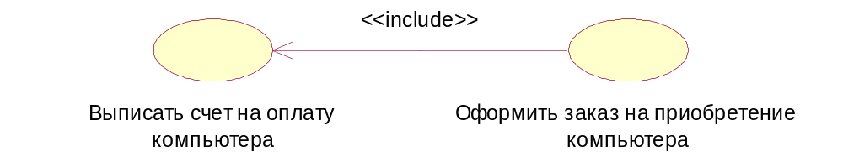
Fig. 1.4 – An example of a graphic image of the relationship of inclusion between use cases.

The extension relation (extend) determines the relationship of the base use case with another use case, the functional behavior of which is not always invoked by the base use, but only when additional conditions are met.
The semantics of an extension relationship is defined as follows. If the base use case performs some sequence of actions that determines its behavior, and there is an extension point to an instance of another use case, then the logical condition of the given relation is checked. If this condition is met, the original sequence of actions is extended by including actions from another use case.
The expansion relationship between use cases is indicated by a dotted line with an arrow directed from the use case that is an extension to the original use case. This line with an arrow is marked with the keyword "extend", as shown in Fig. 1.5

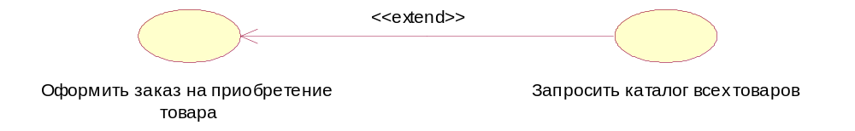

Fig. 1.5 – An example of a graphic representation of an expansion relationship between use cases.

In the example presented above (Fig. 1.5), when placing an order to purchase goods, it is only in some cases that you may need to provide the client with a catalog of all the goods. In this case, the condition for expansion is a request from the client to receive a catalog of goods. It is obvious that after receiving the catalog, the client needs some time to study it, during which the ordering is suspended. After reviewing the catalog, the client decides either in favor of choosing a particular product, or not buying at all. The use option "Checkout for the purchase of goods" can respond to the customer's choice after the customer receives a product catalog for review.

The generalization relation serves to indicate the fact that a use case A can be generalized to use case B. In this case, option A will be a specialization of option B. In this case, B is called the ancestor or parent of A, and option A is a descendant of use case B. It should be emphasized that the descendant inherits all the properties and behavior of its parent, and can also be supplemented by new properties and behavioral features. Graphically, this relationship is indicated by a solid line with an arrow in the shape of an open triangle, which indicates the parent use case (Fig. 1.6).

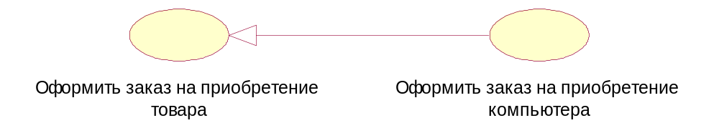

Fig. 1.6 – An example of a graphic representation of the generalization relationship between use cases

The relation of generalization between use cases is used in the case when it is necessary to note that the child use cases have all the attributes and peculiarities of the behavior of the parent options. In this case, child use cases are involved in all aspects of the parent options. In turn, child variants may be endowed with new behavioral properties that are absent from parent use cases, as well as specify or modify behavior properties inherited from them.
One use case may have multiple parent options. In this case, multiple inheritance of the properties and behavior of the ancestor relationship is realized. On the other hand, one use case may be an ancestor for several child variants.
There may also be a generalization relationship between individual actors. This relationship is directed and indicates the fact of specialization of some actors relative to others (Fig. 1.7).

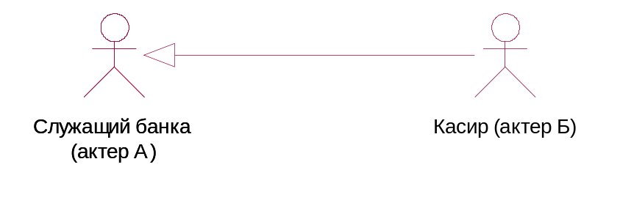
Fig. 1.7. An example of a graphic representation of the relationship of generalization between actors.

For example, the relation of generalization from actor A to actor B marks the fact that each copy of actor A is at the same time a copy of actor B and has all its properties. In this case, the actor B is the parent of the actor A, and the actor A, respectively, a descendant of the actor B. The actor A has the ability to play the same number of roles as the actor B. Graphically, this relationship is also indicated by a solid line with an arrow in the shape of a non-shaded triangle, which indicates the parent actor.

3 Example use case diagram
As an example, consider the process of modeling a system for selling goods in the catalog.
As actors of this system can be two subjects, one of which is the seller, and the other - the buyer. Each of these actors interacts with the considered system of selling goods according to the catalog and is its user, i.e., they both turn to the corresponding service “Place an order for the purchase of goods”. As follows from the essence of the requirements put forward to the system, this service acts as a use case of the chart being developed, the initial structure of which may include only two specified actors and the only use case (Fig. 1.8).

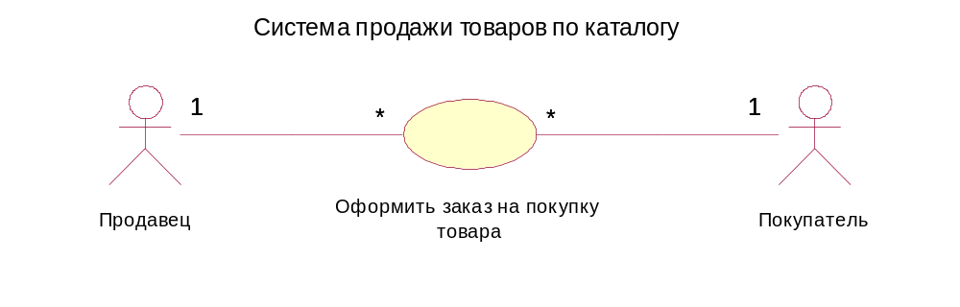
Fig. 1.8 – The original diagram of use cases for the example of the development of a product sales system catalog

The values of the multiplicities indicated in this diagram reflect the general rules or logic of placing orders for the purchase of goods. According to these rules, one seller can participate in the execution of several orders, at the same time, each order can be issued only by one seller, who is responsible for the correctness of its execution and, therefore, will have an agency fee for its execution. On the other hand, each buyer can execute several orders for himself, but, at the same time, each order must be issued for a single buyer, to whom the title to the goods after the payment is transferred.
At the next stage of development, the use option "Checkout for the purchase of goods" can be specified. A more detailed analysis of the sale of goods allows us to single out as separate services such actions as providing the buyer with information about the product, agreeing on the terms of payment for the goods and ordering goods from the warehouse. It is quite obvious that these actions reveal the behavior of the initial use case in the sense of its concretization, and therefore an inclusion relation will take place between them.
On the other hand, the sale of goods in the catalog presupposes the existence of an independent information object - a catalog of goods, which in a sense does not depend on the implementation of the customer service. The product catalog can be requested by the buyer or seller if it is necessary to select a product and clarify the details of its sale. Therefore, we present the service "Request a catalog of goods" as an independent use case.
The resulting specification of refined use case diagram will contain 5 use cases and 2 actors (Fig. 1.9), between which the inclusion and expansion relations are established.

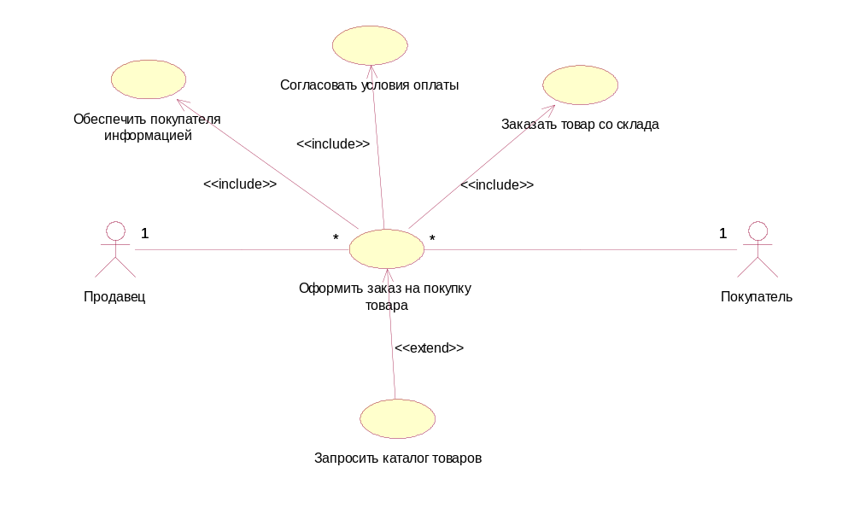
Fig. 1.9 – Refined version of the use-case diagram for the example of the product sales system for the catalog

Further detailing can be carried out on the basis of establishing additional relations like the generalization-specialization relationship for the already existing components of the use case diagram. In the system of sale of goods under consideration, a separate category of goods, computers, can have independent significance and specific features. In this case, the chart can be supplemented with the use of the option "Place an order for a computer purchase" and by the actors "Computer buyer" and "Computer seller", which are related to the generalization relation to the corresponding components of the diagram (Fig. 1.10).

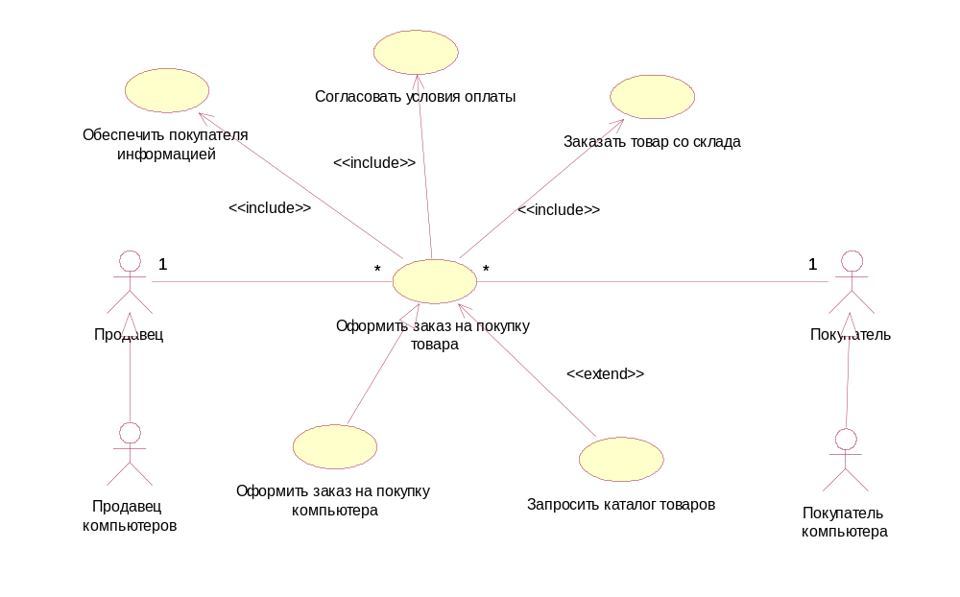
Fig. 1.10 – One of the options for further clarification of the use case diagram for the example of the sale system in question.

It should be noted that the presence of a generalization relationship between the respective components (Seller – Seller of computers, Buyer – Computer buyer, “Place an order for the purchase of goods” – “Place an order for the purchase of a computer”) allows them to inherit the relation of association from their ancestors.

4 Laboratory assignment
1. Guided by the instructions, build a use-case diagram for the ATM system of the system.
2. Demonstrate the result of the work performed.
3. Build a use case diagram for an individually developed system.
4. The report form should be agreed with the teacher.

5 Instructions for performing laboratory work
Step 1 – 1 Create a use-case diagram
Working on a model in the Umbrello UML Modeller environment begins with a general analysis of the problem and the construction of a use case diagram that reflects the functionality of the designed software system. After the appearance of the working interface of the Umbrello UML Modeller program with a blank active class diagram window and the default project name Untitled.
As a project the model of control system will be examined by ATM. Dignity of this project is that he does not require the special description of subject domain, as supposes an intuitional acquaintance with the features of functioning of ATM :) The here developed model of control system is used ATM as a through example within the framework of that the features of development of different diagrams of language of UML are illustrated in the environment of Umbrello UML Modeller.
For the change of the name of project offer the program by default, it is necessary to save a model in an external file on a disk, for example, under the name ATMmodel.xmi. In this case the name will change in the line of heading.
As well as other programs, Umbrello UML Modeller allows to influence the global parameters of environment, such as a choice of types and color for presentation of different elements to the model. Tuning of types, colors of lines and clip arts produced through the operation of main menu : Settings ->Configure Umbrello UML Modeller ->User Interface.

For development of use-case diagram of model in the environment of Umbrello UML Modeller it is necessary to activate a corresponding diagram in the window of diagram. It can be done by next methods:
- to expose a context menu in the browser of project Use Case View and choose New ->Use Case Diagram;
- by means of operation of main menu of Diagram ->New ->Use Case Diagram (Диаграмма->Новая->Diagram of variants of the use).

Table 1.1 – Setting of the buttons of the special bar of tools for the use-case diagram
icon | Pop-up prompt | Setting of the button
 | Select | Converts the image of cursor into a pointer for the subsequent selection of elements on a diagram
 | Note | Adds a note on a diagram
 | Anchor | Adds connection of note with corresponding graphic elements of diagram.
 | Label | Adds a text area on a diagram.
 | Box | Adds a box (package) on a diagram.
 | Actor | Adds on the diagram of actor.
 | Use Case | Adds the variant of the use (use-case) on a diagram.
 | Association | Adds an association on a diagram.
 | Directional Association | Adds the directed association on a diagram.
 | Dependency | Adds the relation of dependence on a diagram.
 | Implements | Adds the relation of belonging on a diagram.

Thus a new window appears with a clean worker by the sheet of use-case diagram and the special bar of tools, it contains the buttons with the image of clip arts necessary for development of diagram of variants of the use. Setting of the separate buttons of this panel can be known also from pop-up prompts that appear, if to bring and detain on some time the pointer of mouse above one or another button.

Step 2 – Addition of actor on the diagram of variants of the use and editing of his properties
For addition of actor on the use-case diagram it needs by means of the left button to the mouse to push the button with the image of icon of actor on the special bar of tools, to release leave mouse button and click leave mouse button on available space of working sheet of diagram. On a diagram the image of actor will appear with the markers of change of his geometrical sizes and offer the program name by default "new _ actor". For the developed model of ATM an offer the program name of actor it is necessary to change on "Client of ATM" (look a picture).

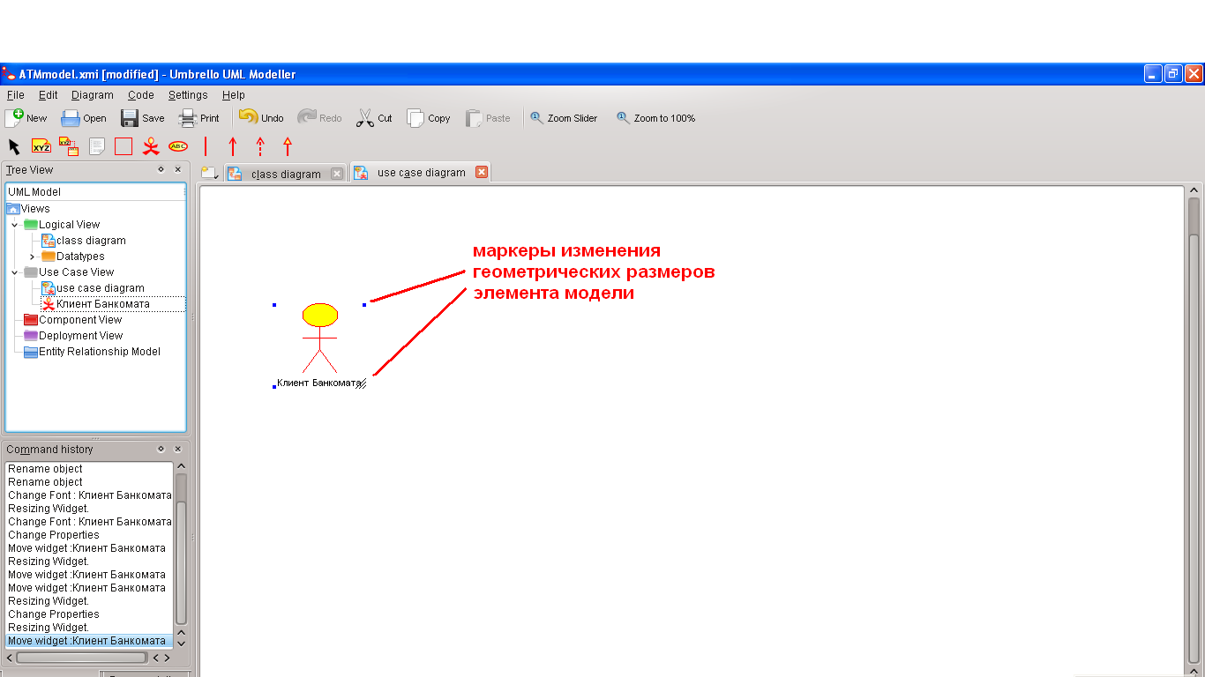
Fig. 1.11 – Use-case diagram after addition on her actor and the change of graphic sizes of actor

To change the location of image of clip art of model, it is necessary the click of leave mouse button to distinguish him in the scratch area of diagram, and, not releasing the left button, to transfer diagrams to the necessary place. Thus the distinguished element by sight differs from other the presence of markers of change of his geometrical sizes in form small black squares.
To change the graphic sizes of image of model element, foremost, it is necessary the click of leave mouse button to distinguish him in the scratch area of diagram. It is further necessary to bring the pointer of mouse to the necessary marker of geometrical sizes of element and push the left mouse button. A rectangle will appear as a result of these actions, representing the borders of the chosen geometrical element, will change the sizes on a horizontal and vertical line. Whereupon, not releasing leave mouse button, it is necessary diagonally to change the sizes of this rectangle necessary character.
The name of the element placed on a diagram a developer can change either right after addition of element on a diagram or during the subsequent prosecution of project.
For any clip art of model on a click the right mouse button on the chosen element is cause the context menu of this element, among the operations of that there is a point of Properties. In this case an additional dialog box appears with the special insets, in the fields of input of that it is possible to bring all information on this element. For the added actor "Client of ATM" the window of specification of properties looks like the following.

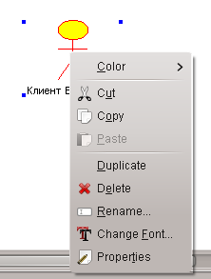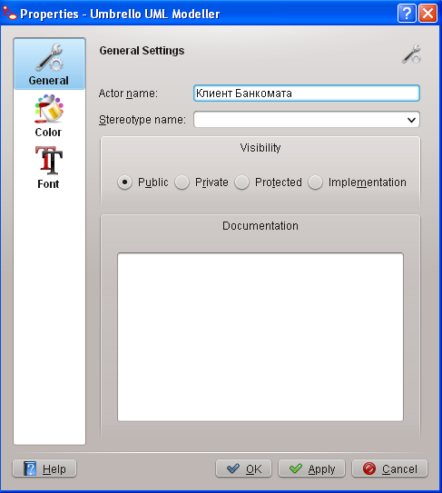
Fig. 1.12 –

It should be noted that opening the dialog box of properties of any element of model is possible also a click by the right mouse button on the graphic image of this element on a diagram. Although in the environment of Umbrello UML Modeller an actor is a class, for him it is uncorrect to specify attributes and operations, as an actor is external in relation to the developed system essence. For an actor “Client of ATM” it is possible to specify his setting in a model. To that end it is necessary to change his stereotype and add text of documentation. For the change of stereotype in the inlaid list of Stereotype it is needed to collect the line of "Business Actor". For adding of text to documentation to the section of Documentation it is necessary to enter text: "Any physical person using services of ATM" and to push the button Apply or OK. After the change of these properties of actor “Client of ATM” the window of specification of properties will look like the following.

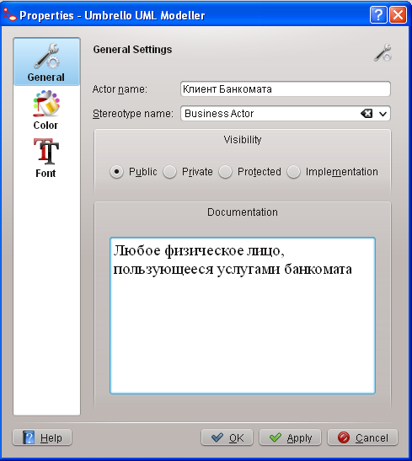
Fig. 1.13 –

Step 3 – Addition and editing of use-case.
For addition of variant of the use on a diagram it needs by means of the left button to the mouse to push the button with the image of variant of the use on the special bar of tools, to release leave mouse button and click leave mouse button on available space of diagram. On a diagram the image of variant of the use will appear with the markers of change of his geometrical sizes and offer the program name by default "new _ usecase". For the developed model of ATM an offer the program name of variant of the use it is necessary to change on "Removal of наличных on a credit card".

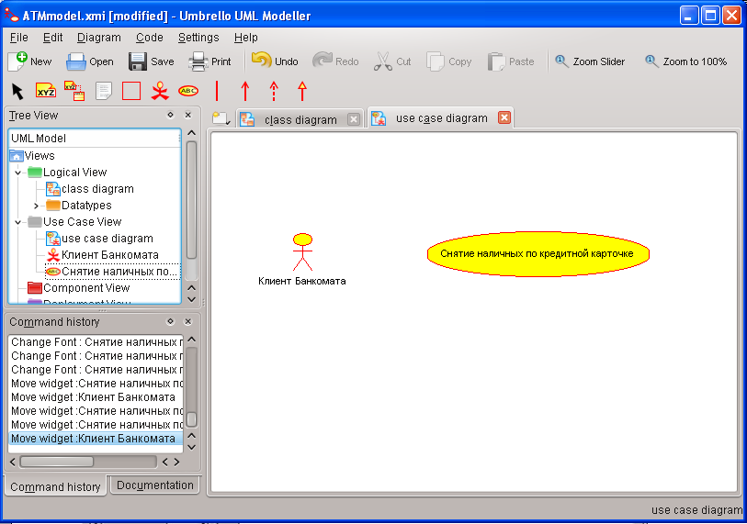

Fig. 1.14 – Use-case diagram after addition on her variant of the use

For clarification of properties of this variant of the use it is necessary to open the dialog box of his properties (Properties), for example, by means of click by the right mouse button dark-and-light this element on a diagram. For the change of stereotype in the inlaid list of Stereotype it is needed to choose the line of Business Use Case. For adding of text to documentation to the section of Documentation it is necessary to enter text: the "Basic variant of the use for the developed model of ATM" and to push the button Apply or OK. After the change of properties of variant of the use the window of specification will look like the following.

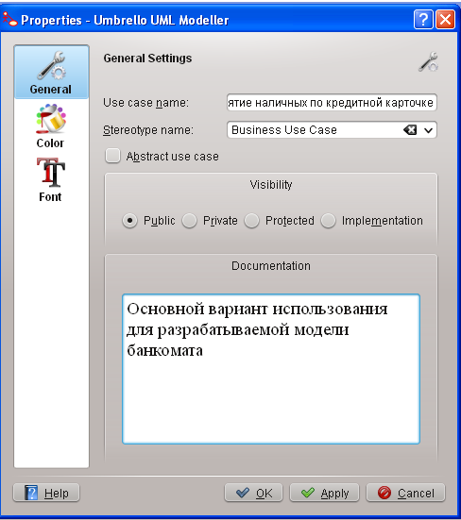
Fig. 1.15 –

Step 4 – Addition of association
For addition of association between an actor and variant of the use on a diagram it needs by means of the left button to the mouse to push on the special bar of tools the button with the image of icon of the directed association, to release leave mouse button, click leave mouse button dark-and-light actor on a diagram and to release her dark-and-light variant of the use. As a result of these operating on a diagram an image will appear of association, connecting an actor with the variant of the use.

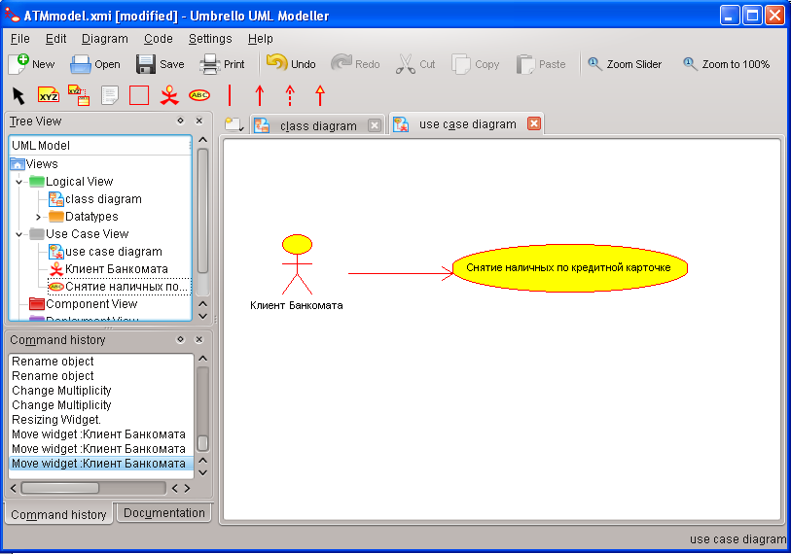

Fig. 1.16 – Diagram of variants of the use after addition on her of the directed association

Step 5 – Addition of relation to dependence and editing of his properties.
For addition of relation to dependence between two variants of the use on a diagram it is necessary the method preliminary considered higher to add the second variant of the use with the name "Verification of Pin-code". After it by means of leave mouse button to push the button with the image of icon of dependence on the special bar of tools, to release leave mouse button, click leave mouse button dark-and-light variant of the use "Removal of наличных on a credit card" and to release her dark-and-light variant of the use "Verification of Pin-code". As a result of these operating the image of relation of dependence, that connects two chosen variants of the use, will appear on a diagram.

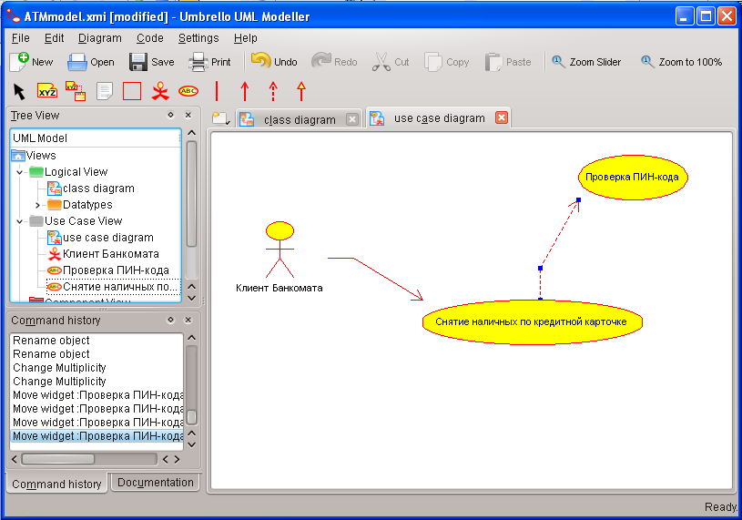
Fig. 1.17 –

Step 6 – Final construction of use-case diagram.
For the final construction of use-case diagram for the examined model of ATM it is necessary to execute next actions:
1. To add an actor with the name "Bank", for that to choose the stereotype of "Service", meaning, that ATM uses some services of "Bank" as service.
2. To add the use-case "Receipt of certificate about the state of account" for that to choose the stereotype of "Business Use Case".
3. To add the use-case "Blocking of credit card".
4. To add the directed association from business-actor “Client of ATM” to the use-case "Receipt of certificate about the state of account".
5. To add the directed association from the use-case " Removal of money of c of credit card" to service "Bank".
6. To add the directed association from the use-case "Receipt of certificate about the state of account" to service "Bank".
7. To add the relationship of dependence with the stereotype <<include>>, directed from the use-case "Receipt of certificate variant of the use about the state of account" to the use-case "Verification of Pin-code".
8. To add the relationship of dependence with the stereotype <<extend>>, directed from the use-case "Blocking of credit card" to the use-case "Verification of Pin-code".
Executing these actions is suggested independently. Thus the relationship of dependence with the stereotype <<extend>> on this diagram means the following. The use-case "Blocking of credit card" will be executed only in case that it will be set as a result of verification of Pin-code, that a corresponding credit card is lost by her proprietor or confessed by invalid. The diagram of variants of the use built thus will have a next kind.

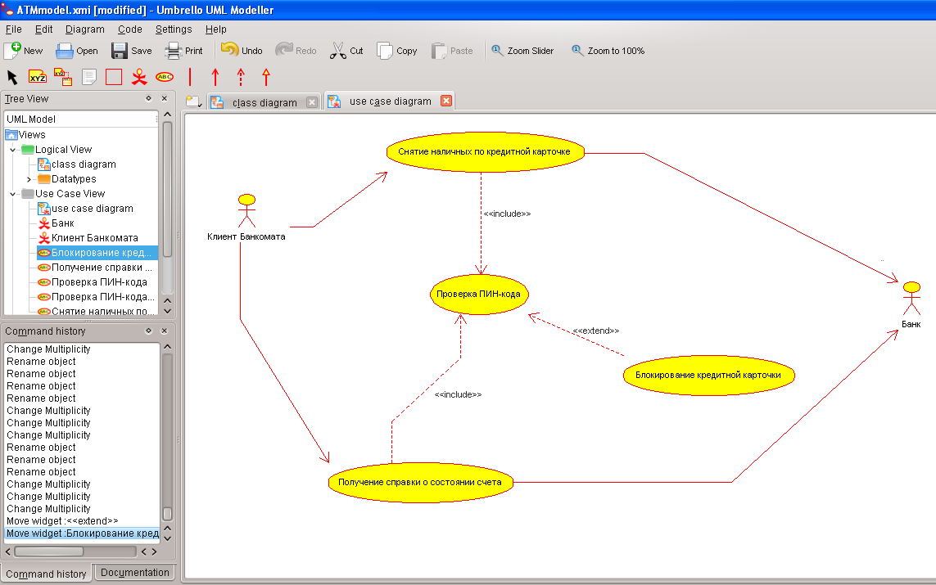

Fig. 1.18 – Final type of diagram of variants of the use for the developed model of ATMs.

A diagram of variants of the use is high-level conceptual presentation of model, therefore she must not contain the too much variants of the use and actors.
In subsequent the built diagram can be changed by means of addition of new elements, such as variants of the use and actors, or their moving away. For moving away of any clip art from the diagram of him it is necessary to distinguish on a diagram and press the key of Delete on a keyboard. Thus the distinguished element will be removed from an active diagram, but not from a model. For moving away of element not only from a diagram but also from the model of project it is necessary to distinguish a delettee on a diagram and take advantage of operation of context menu on the inset of Use Case Diagram in Tree View Delete.
During work with relations on the diagram of variants of the use it should be remembered about setting of corresponding relations in notation of language of UML. The question is that if for two elements the chosen type of relation is not possible, then in most cases the program Umbrello UML Modeller will report about it to the developer, and a corresponding flow line will not be added on a diagram. After completion of session above a project the executed work must be saved in the file of project with expansion ".xmi". It can be done through the menu of File -> Save or File -> Save As. Thus all information about a project, including diagrams and specifications of elements, will be stored in one file.

Контрольные вопросы:
1. Предназначение диаграммы вариантов использования?
2. Какие основные сущности Используются при построении ДВИ?
3. Какими отношениями могут быть связаны сущности диаграммы….7

Список литературы
1. Леоненков А.В. Самоучитель UML. 2-е издание - СПб.: "БХВ-Петербург", 2004. - 432 с.
2/ Буч Г., Джекобсон А., Рамбо Дж. Язык UML. Руководство пользователя - М.: ДМК, 2000. - 432 с.
3/ Буч Г., Рамбо Дж., Якобсон А. UML: специальный справочник - СПб: "Питер", 2001. - 656 с.

1/ Леффингуэлл Д., Уидриг Д. Принципы работы с требованиями к программному обеспечению. Унифицированный подход - М.: "Вильямс", 2002. - 448 с.
--------
• Starr L. Executable UML. How to build class models - Prentice Hall PTR, 2002. - 418 p.
• Wampler B.E. The Essence Object-Oriented Programming with Java and UML - Addison-Wesley, 2002, - 290 p.

